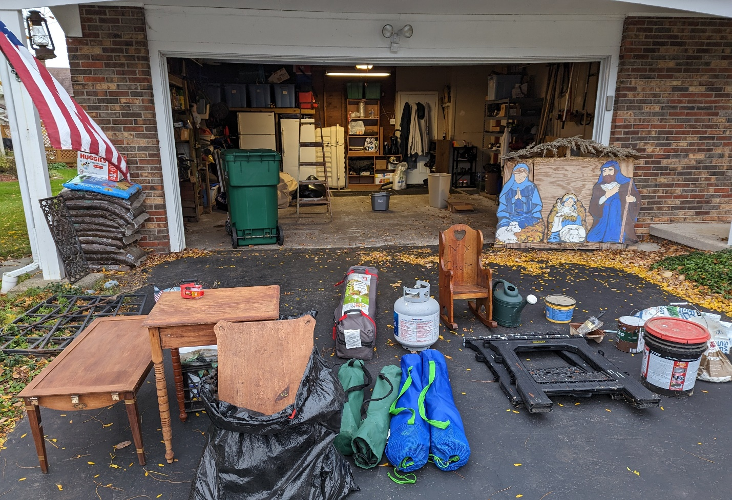
The driveway already was cluttered when only a third of the garage contents were emptied.

Reflections of a River Rat:
Transforming the nightmare
on Rolling Meadows Way

The situation had become obvious, almost biblical. There was no room for Mary and Joseph at the inn more than 2,000 years ago. Now they were being turned away from my garage.
The decision on a retired Christmas display was one of the painful but necessary choices I had to make last week when I tackled the 20x20 nether region attached to my home. This was no Garage Mahal; more like the Garage From Hell.
The six rusting steel flag poles were tossed with the glass growler, in case I resumed making homemade beer. A half dozen car mats from four minivans ago. 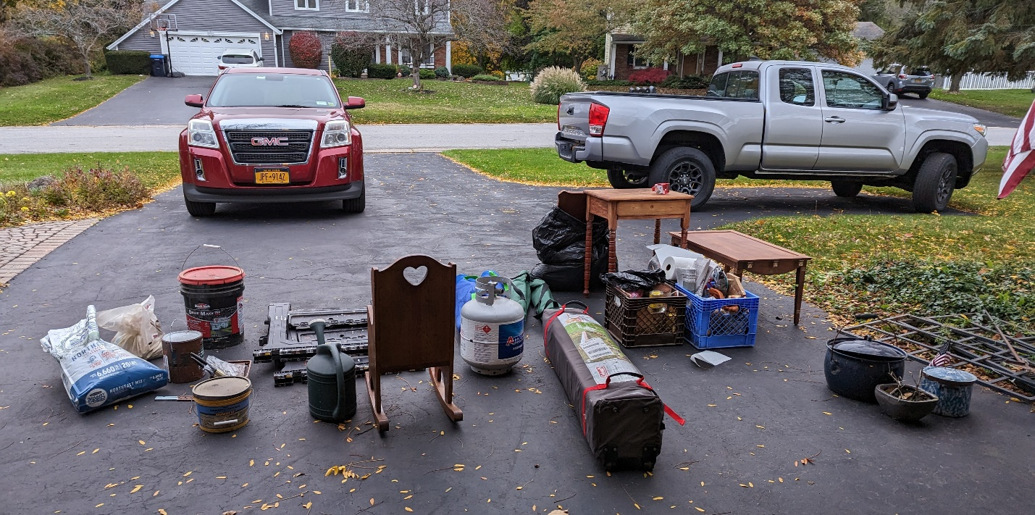One strategic move was to get all the stuff moved back inside before the rain arrived.
The lengths of old clothesline because you never know when you need to tie something down.
No, nah and nope. Lengths of wood, shovel handles, my rack of yardwork clothes – they were history. It was too difficult to move when you pulled the cars inside. I was tired of stepping around plastic crates of furniture refinishing supplies. I was in the throes of a work snit. If I hadn’t used it in the last 5 years, it was going.
This upheaval started when Mrs. Wonderful of 38 years, Mary, contracted Covid.
The upshot was that I was under quarantine for 5 days but needed to maintain my distance from her. Between heart and diabetic concerns, my cardiologist had issued a no-frills warning three times within one appointment – “If you get Covid, it’ll kill you.’’
When I thought I had scrolled to the end of the Internet, when I refrained from fumbling with the piano, when I ran out of irritating jokes that interrupted her Netflix binge, I decided to let her suffer more peacefully through the coughing and congestion. At 38 degrees, it was too cold to quarantine on the golf course, so I tackled the garage, the nightmare on Rolling Meadows Way.
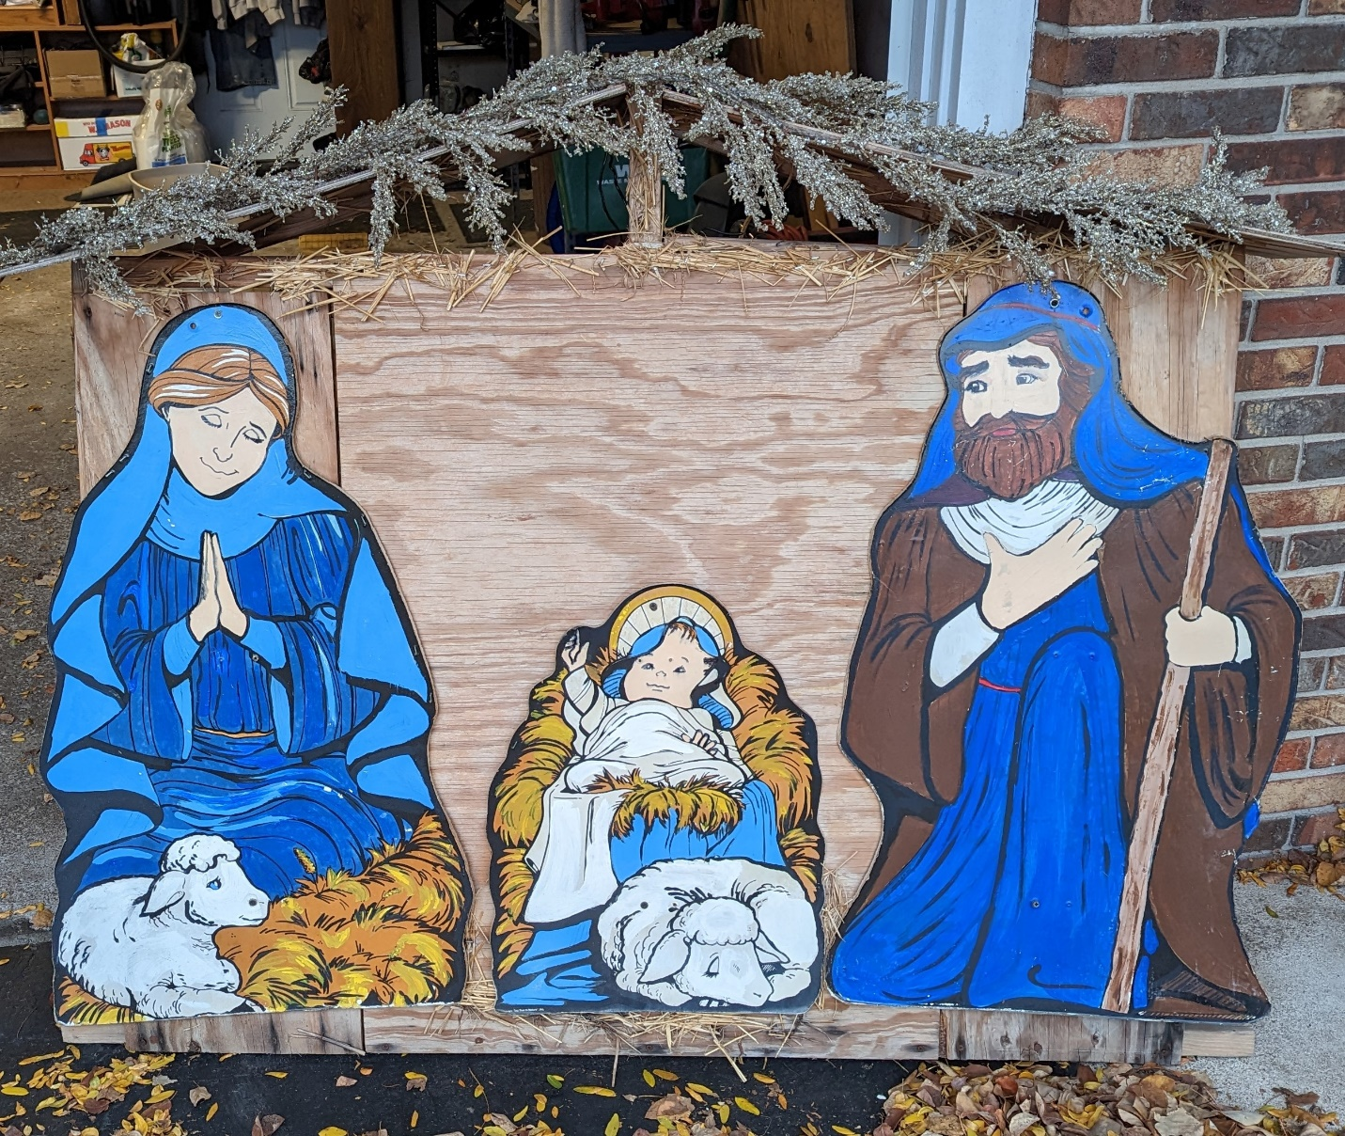My Christmas display was a fixture on the front lawn for several years. My sister refurbished it, but eventually it was replaced with lightweight, white silhouettes.
The first step was zero-basing everything. The shovels and rakes hung neatly on the wall, the snowblower and push mower, the garbage and recycling totes – all were safe. Everything else had to be sorted on the driveway.
The three partial bags of grass seed, potting soil, several watering cans and handtools were dumped in one pile. The lengths of plywood, decking, crown moulding, baseboards and old shelving formed another. The pop-up tent and the grandson’s toys made a third. The furniture refinishing projects and bins of rags, solvents and putty knives formed a unit.
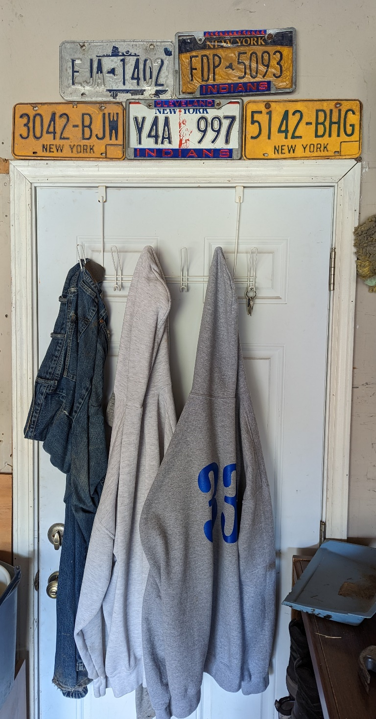
The Holy Family was on the move too. Mary, Joseph and the baby Jesus were one-dimensional silhouettes tacked to a heavy, amateurish creche I made 25 years ago from plywood and scrap lumber. They had lost their luster a few years back, but my crafty sister Maureen, the retired art teacher, had given them a fresh coat of paint. This wasn’t as dramatic as the restoration of the Sistine Chapel ceiling, but it was a big improvement.
I swear the Virgin Mother’s gentle eyes followed me as I moved around the garage. What cold-hearted Irish Catholic product of the 1960s could toss the mother of the Lord onto the scrap heap? She earned a reprieve. I removed her figurine and tossed the wood. I figured I owed her that for taking her son’s name in vain over so many missed three-foot putts.
Before I could move stuff back indoors, I had to blow out the dust and vacuum leaves from the shelves, floors, nooks and crannies. The shelves were the hardest part. I had to rethink how everything would be arranged. My siblings claim – or is it assert? -- that thinking is a challenge.
The sneakers, boots and hockey skates were an easy fit on one shelf, but you must sort by gender. Which items will be shelved closest to the kitchen door? Do I really need a paint-marred sweatsuit and tar-stained shirt and pants? It wasn’t an either-or situation; they both got tossed.
My last act was to install old license plates and Cleveland Indians brackets over the rear door.
The bicycles that were crammed into a dusty corner went up on wall hooks. Liam’s bike hadn’t been ridden in eight years since he moved to Los Angeles. It was donated. All the buckets and brushes found a home together, and the Shop-Vac and canister vacuum found a dedicated space.
After five hours of sorting, sifting and self-satisfaction, I summoned Herself to the garage and fished for a compliment. She was impressed.
“Well Mary, it’s been 38 years. Think we can do another 38?’’
Without hesitation, she replied: “Sure, I don’t plan on getting hearing aids.’’
Jim Holleran, a Morristown native, is a retired Rochester teacher and former sports editor of the Democrat and Chronicle. Reach him at jimholleran29@gmail.com or view past columns under “Reflections of River Rat’’ at https://hollerangetsitwrite.com/blog/

