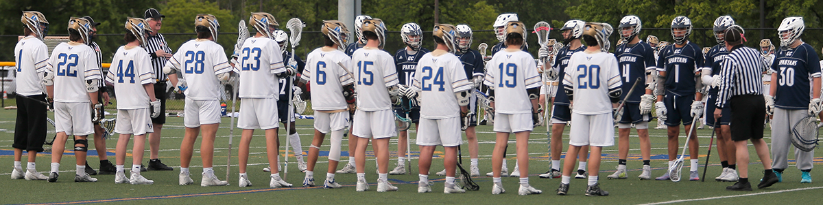Jim Holleran, left, and his crew listen to final instructions during a first-round playoff game.

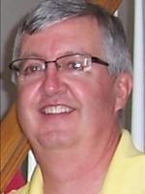
Reflections of a River Rat:
Generations later, we still learn
life’s lessons on the playing field
My guys saved a dopey teenager from himself last week. He was wallowing in anger and pity and a lack of self-awareness. I am sure his foul language embarrassed his parents. I know his behavior irked his coach and teammates. Ultimately, he reminded me of myself.
My memory is rewinding to last week when I was assigned my first Section V semifinal game as chief bench official, CBO in lacrosse parlance. It was an honor to be selected for the playoffs, but I’d never worked that role. We don’t use CBOs in two- or three-man crews during the regular season, but when the playoffs arrive, we add an off-field referee to work the sideline between the benches.
My assigner assured me it was a simple role – help with offsides calls, confirm that substitutions are legal, and grant timeouts to the benches when possession of the ball matters mightily in a tight game. He reminded me – don’t overthink it.
My crew chief had a different take. During our pre-game meeting in the school parking lot, he encouraged me to be active. “Don’t be afraid to come out strong if you see something that absolutely has to be called.’’
Things were going swimmingly in a back-and-forth game. I granted three timeouts through the first three quarters, and passed on another for lack of possession. Our crew was sharp, deftly handling a player on each team who was 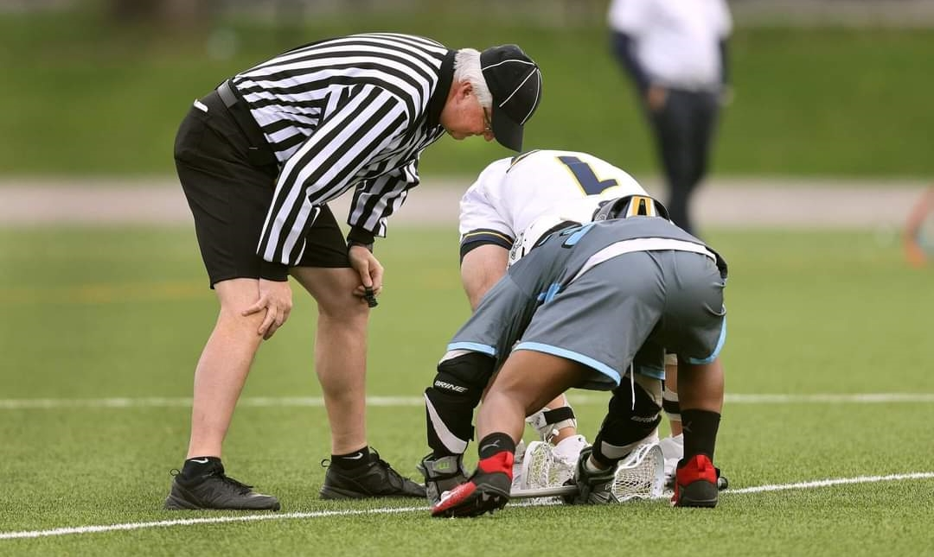One of my first mentors advised me to apply the rules the same way whether it is the first or last minute of the game. I like to say that I am ruining teen-aged boys lives.
not tripped nor illegally checked, but who simply slipped on the wet turf. Two good no-calls. With three minutes left in the third quarter, the tension devolved into chaos.
The dopey teenager – the goaltender -- rushed to challenge a point-blank shooter, wrapped him in an illegal hold, saw the shooter flick the ball into the goal, watched as a penalty flag flew, and witnessed his opponents go bonkers in celebration. The goaltender temporarily lost it.
He slammed his stick on the ground in front of the crease. He screamed F-bombs. A flag flew. He continued an obscenity-filled rant all the way to the sideline. As he approached me about 10 yards from the bench, he dropped another string of F-bombs, ripped off his helmet with two hands, and threw it past his teammates and against the chain-link fence.
In my first CBO role, I hurled my penalty flag and extended both arms. We have nicknamed this signal the “full bird.’’ It was an unsportsmanlike conduct call all day long. There was no other recourse.
Our crew huddled near midfield to sort this mess out. We had a hold by the goalie, which was wiped out by the goal. We had an unsportsmanlike conduct (USC) on the goalie for his initial rant. We had a second USC for his sideline meltdown. But wait, there’s more. A defenseman had delivered a crosscheck to the head of another player, and that merited a 2-minute penalty.
The team was in a dire situation. It already was down a goal, the goalie likely would be ejected, and the opponents would have a two-man advantage for at least 90 seconds. Nobody could re-enter the field until all the time was served.
That’s when we saved him. The crew chief, a veteran of Division I college games, figured that two USCs (automatic ejection) would bar the goalie from a possible championship game. So we dumbed-down the first USC to a conduct foul. His coach had the good sense to bench him for the rest of the game.
Their opponents only scored once in the ensuing penalty time. The goalie buried his head in his hands on the bench and watched solemnly as his teammates rallied in the fourth quarter. His backup made two saves in the last 15 minutes, including a flurry of shots in the last minute for a one-goal victory.
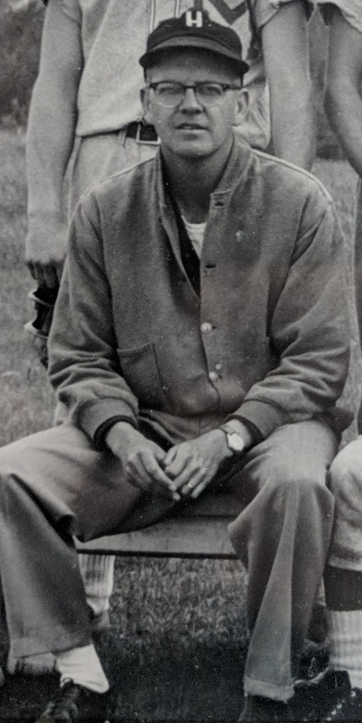
Three days later with his composure restored, the goalie started the championship game. Even though his team lost 8-6, he can tell his grandchildren how he experienced the thrill of the title game and made eight saves. He can thank my crew chief for managing the situation.
By coincidence, 40 years passed this week since my football, soccer and baseball coach, Fran Holleran, who doubled as my father, died unexpectedly on June 7. I can be thankful for his patience and the lessons he imparted when I was a dopey teenager at Morristown Central School. Credit him with a save.
He had to be embarrassed when I fought with my best friend over a pair of baseball pants. Coach left us off the team bus and sent us home. He had to be embarrassed when my younger brother threw a bat at me and I jumped him during practice. I was suspended until I could figure out a better attitude.
He had to be embarrassed when I mouthed off on the baseball bus about a weak-hitting Hammond player so he resorted to some humility training. “Hey Mr. Big Mouth,’’ he said from the front seat of the bus with the entire team listening. “You didn’t knock down any fences this spring.’’ Point taken.
It was his way of saving me from myself. To quote my late mother Eileen, “It’s what you learn, after you know it all, that counts.’’
The dopey goaltender has one more season of eligibility. I hope he learns as much as I did when I knew it all.
Jim Holleran, a Morristown native, is a retired teacher and registrar for the Rochester City School District, and former sports editor of the Democrat and Chronicle. Reach him at jimholleran29@gmail.com or view past columns under “Reflections of River Rat’’ at https://hollerangetsitwrite.com/blog/

