
Reflections of a River Rat:
Apple pie – a recipe for kindness
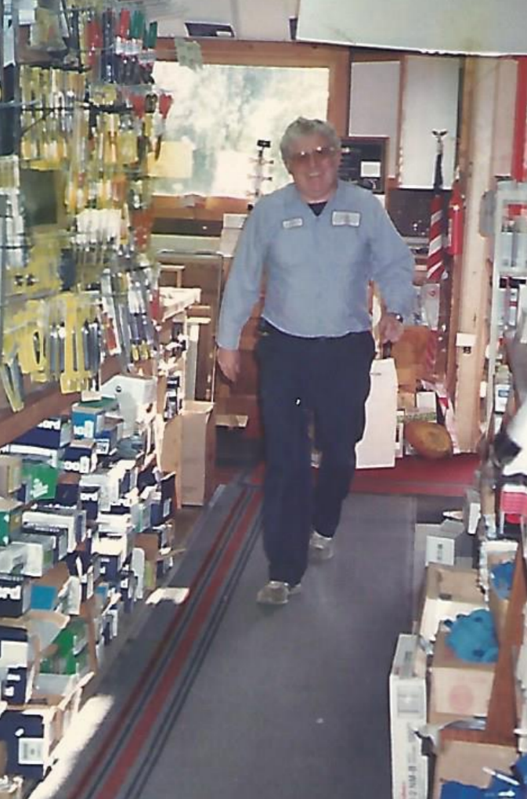
The origin of the PIE Network began about 20 years ago when I was invited to sample an apple pie made by Jim Spilman, who operated Morristown Fuel & Building Supply. He ran his business like George Bailey ran the Bailey Building & Loan; he was generous to everyone.
Jim Spilman patrolling the aisles at Morristown Fuel & Building Supply.
If Jim Spilman, athlete, Navy veteran, handyman and gentleman, could make apple pies, I reasoned, so could I. Besides, I had learned a few things from my grandmother when she spent her winters with us. First, “The Lawrence Welk Show’’ takes priority over “Hockey Night in Canada.’’ Second, you can help in the kitchen if you listen and don’t act out.
So I bought a readymade crust from the supermarket, cut my apples, and assembled what I thought was my first “masterpiece.’’ It was immediately panned by my teen-aged nieces, who ridiculed the store-bought crust. They were correct – it tasted like a glob of lard.
Then I tasted a perfect pie at a friend’s house in Ohio. Using her recipe, I made my own crust. I chopped my apples finer than Jim Spilman’s so they would bake all the way through. And I learned to add tapioca to keep the filling from running out into the pan once you cut the first slice. My mediocrity rose to a level of excellence.
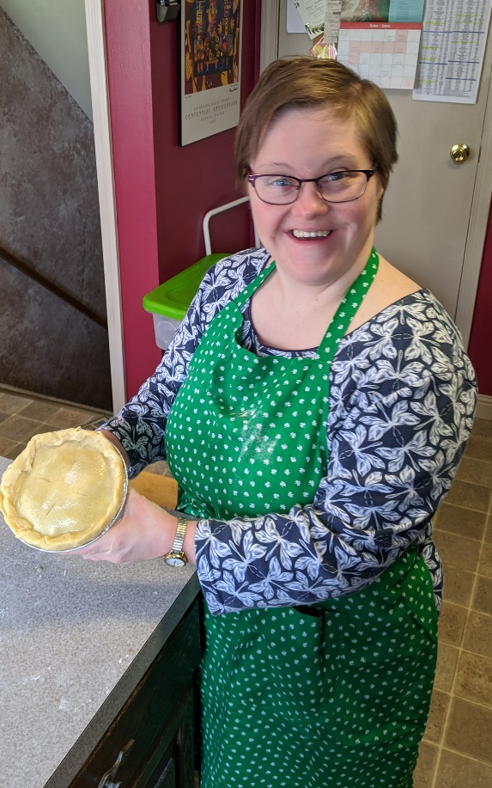
Simultaneously, the charitable aspect was overtaking the enterprise. Recently, a neighbor’s father died; he received a pie. A golf buddy underwent ankle surgery; a pie reached his doorstep. A couple spearheaded a charity organization, Sleep in Heavenly Peace, to make beds for needy children; they found a pie on the hood of their car.
That’s the way the PIE Network operated, but it was sidelined about a year. My chief volunteer backed off over Covid concerns. Our appliances, cabinets and counters were donated to Habitat for Humanity. What was left of our kitchen was reduced to a plywood floor and exposed studs during a renovation. But two factors coalesced last week – the kitchen renovation was completed and my daughter Katie Holleran’s job closed for a week while the Omicron variant spread like wildfire.
Katie’s arrival jumpstarted the work better than Julia Child or Gordon Ramsay. There were apples to skin and chop. She mixed the dry ingredients while I made the dough. I ran the rolling pin; she filled the shells. I crimped the edges; she applied the egg whites and coarse sugar.
Katie has taken over for my retired music teacher buddy, Dan Macpherson. He was lured by a sense of volunteerism and memories of his college job as a short-order cook. He liked the aspect of donating pies to people in need or under duress.
As Dan and I cut and chopped, we started making brief videos and posting them on Facebook. If there was MSNBC and Fox, we decided our videos should be dubbed the PIE Network. The self-deprecating jokes, golf talk, war stories from elementary teaching, the rips on Trump, and the laughs about conservative whackos drew plenty of comments on the Internet. Soon we roped in our conservative friend, Jim Nugent, and reached another level of satire. It all helped to boost our piemaking.
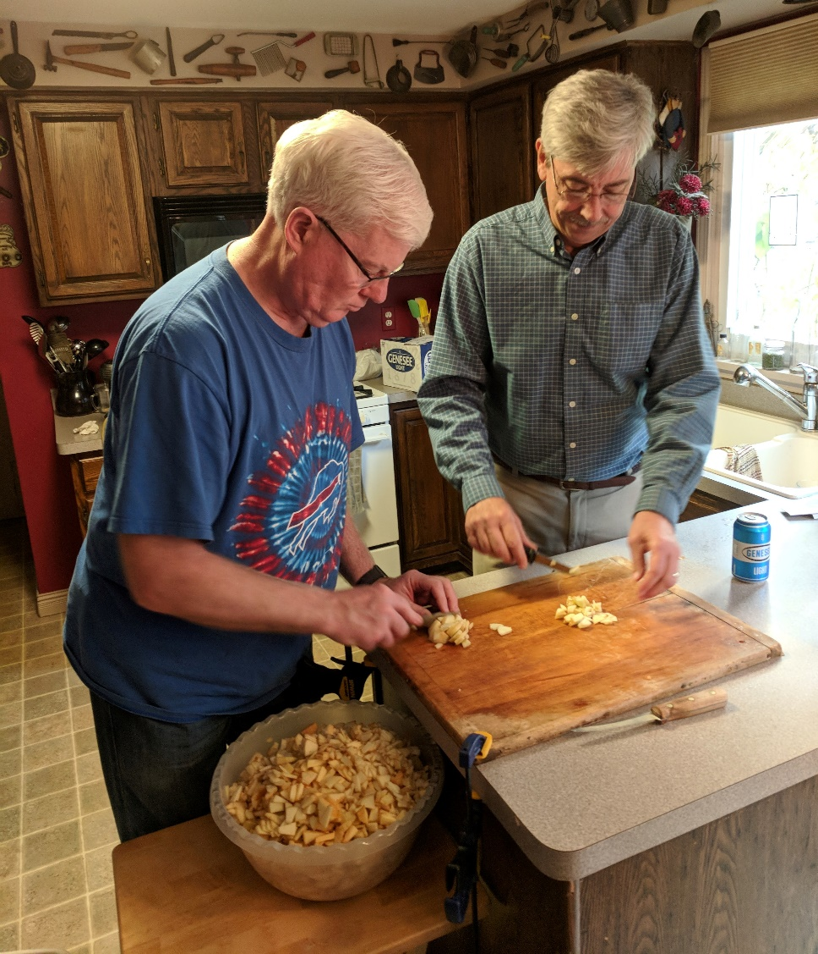
The more we cut, the more we refined the process. Macpherson introduced the cordless drill. He plunged a paddle bit into the core of the apple, spun it, and held the peeler against it. The peel came off almost instantly. Stunningly efficient.
Liberal Dan Macpherson and conservative Jim Nugent crossed a political divide to cut apples for the PIE Network.
Later, our Ohio friends, John and Kathy Aldrich, sent us two aprons. One for Katie – Lead Assistant; another for me – CEO.
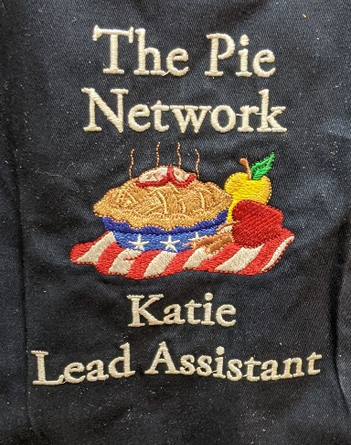
Our friend, JoAnne McNamara, led us to a motherlode of apples. Her neighbor offered the crop from four trees alongside his house. We filled 47 plastic grocery bags with apples, then stored them in my garage. Macpherson and I spent the fall peeling and chopping. We stored the processed apples in home freezers of the Irish Mafia – Mahany, McNamara and Holleran, all basketball parents.
Apron insignia from Kathy Aldrich.
We had a formula. Retrieve two one-gallon bags of frozen apples, open a beer, turn on the Irish music, and let the chirping begin. Two bags of apples yielded about seven pies. The PIE Network flourished.
The delivery style has remained fairly stealthy. Line a pizza box with tinfoil, tape a PIE Network label to the lid, creep up on an unsuspecting house, and leave the pie. Our style is hit-and-run; we don’t stick around for thank yous.
Our network has developed a wide reach. When I was in Morristown last summer, the network delivered to one of my father’s former MCS colleagues who lost a child to cancer. My cousin called from Utica. She wanted to recognize her old neighbor, now in Rochester, who had lost a sister.
I hope Jim Spilman would be impressed. He brought out the George Bailey in me.
Jim Holleran, a Morristown native, is a retired teacher and registrar for the Rochester City School District, and former sports editor of the Democrat and Chronicle. Reach him at jimholleran29@gmail.com or view past columns at https://hollerangetsitwrite.files.wordpress.com under Reflections of a River Rat.

