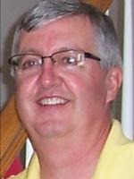
Reflections of a River Rat:
Motorists who drive me crazy
By Jim Holleran
This rant about drivers will sound odd coming from the guy who often travels a few tenths of a mile with his blinker stuck in the ON position. But that’s the result of driving a 2007 Kia Sportage with 145,000+ miles. I don’t want to be the clueless old guy driving for 10 miles down the Thruway; my blinker just sticks.
Back to my rant. It’s about dogs in cars. I laughed at first last week when a girl overshot her mark at McDonald’s and her dog in the backseat stuck his head into the drive-through window. She backed up her car and left with her order. I have to presume she was fiddling with her cellphone.
When it was my turn, the server was still stunned. The employees wear gloves and masks, but dogs don’t care about hygiene. If the dog had licked the rim of my drink or messed with my bag, I would want them to start over.
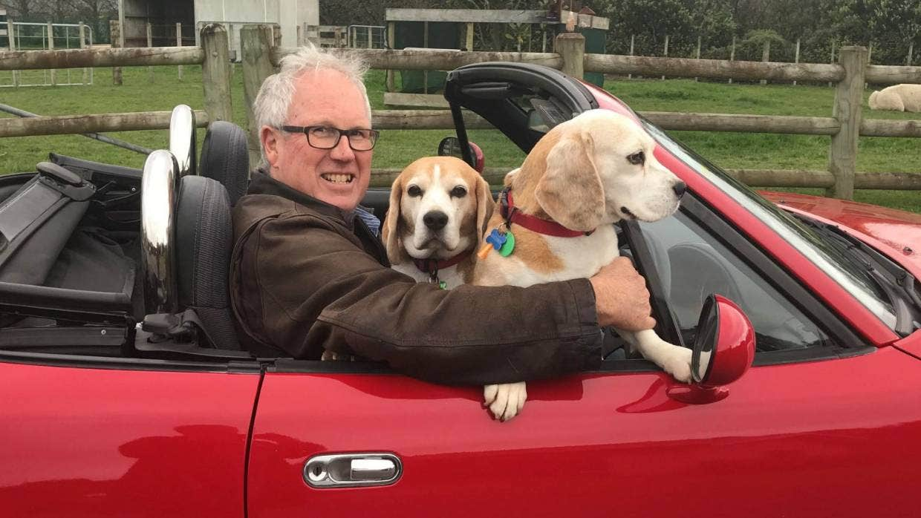
New Zealand driver illustrates the insanity of driving with dogs in your lap.
This incident stuck in my head. I recalled how the dog ran to the other side of the backseat and was panting out that window. So you can imagine there’s a good chance that this dog must be a distraction when the car is moving.
At least the dog was in the back seat. Have you seen the fools with a dog in their laps while driving? You may need a therapy dog in this age of anxiety and self-pity, but leave it at the nursing home. FiFi belongs anyplace but in your lap while you’re going 65 mph or more in traffic.
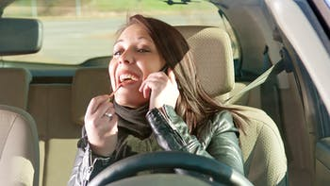
Distracted driving is the No. 1 cause of accidents in the United States, and the problem is growing each year. We know the biggest offender is the driver who reads a phone or texts while he/she is driving. We all have seen the woman applying makeup at an intersection, then continuing to do so when the traffic leaves the light. Eating while you drive is high on the list too. I am guilty of eating, but not grooming. All the makeup in the world could not improve my ugly mug.
Each time I run errands, I’m reminded of the bad habits on the road roadways:
Right on Red, Forget the Stop: This one is for the guy last week in the white Porsche who rolled up to a busy intersection, didn’t come to a full stop and ignored one of the fundamentals. You wait for the intersection to clear. He did not. As I passed through, he turned into the inside lane. It was agitating to play defense by hitting the brakes. I once let this stuff pass, now I hit the horn. It’s like your BS index while refereeing – I don’t play the nice guy and listen to sideline conspiracy theories any longer; I just blow the whistle and eliminate the crap.
Beat the Clock: This is my least favorite game of chicken. The driver arrives at a three-way stop inside a shopping center and wants to make the light for the main highway. You arrive first, but the other driver – usually a she – rolls through the sign because she wants to be first. At other times, a driver rolls through a sign to beat the traffic entering from the main highway. Enough! Follow the sign – come to a complete stop.
Rebel Without a Cause on Green – I tried this once. The light turns green, then I count “one thousand one,’’ just to see how the driver behind me – usually a he – will react. Occasionally, I hear their horn. Our society has become obsessed with the jackrabbit start. I realize some distracted fools are playing with the phones; others are patiently looking for any distracted fool who might run a light. But entitled impatient drivers love that horn.
“Always on My Mind:’’ This isn’t a Willie Nelson song. It’s something I’ve been carrying with me for 48 years.
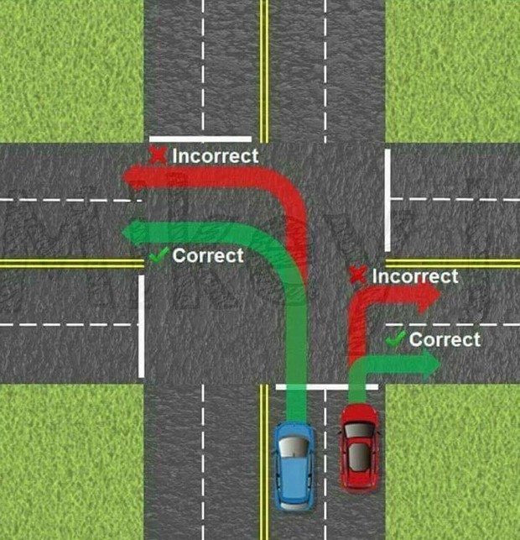
I flunked my driver’s test in 1973 in Ogdensburg by turning into a two-lane, one-way street. My error was turning into the far lane.
Every day I watch people making the same mistake at busy intersections. Usually, there’s no consequence. Occasionally, the offenders will slow traffic or even threaten an accident by cutting off another driver. It always reminds me of my mistake that sunny weekday morning years ago.
No Good Deed Goes Unpunished: I’m a kind person, and I appreciate acts of kindness. But I will never understand the drivers who insist on stopping to wave me through a crosswalk, or insist that I jaywalk across a busy street while traffic backs up behind them. I can wait. I should wait. That’s the rule! Maybe they carry guilt from a long time ago or they’re feeling remorse from arguing too often with their spouse (is that possible?). Regardless, keep moving. You’re beholden to the drivers behind you and their 3,500-pound vehicles, not the pedestrian standing next to the road.
All these faux pas make me want to reach for my rosary and, to quote the late Eileen Holleran, “make a lap around the beads.’’ I’ll wait until I’m parked.
Jim Holleran, a Morristown native, is a retired teacher and registrar for the Rochester City School District, and former sports editor of the Democrat and Chronicle. Reach him at jimholleran29@gmail.com or view past columns at https://hollerangetsitwrite.files.wordpress.com under Reflections of a River Rat.

