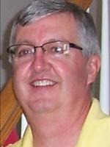
Reflections of a River Rat:
It’s bed time – sanding, building and delivering
By Jim Holleran
I’ve become a disciple of those three little words of a love affair – cut, sand, drill. They are so enthralling that I added three more – brand, stain and deliver. That led to three more – unload, assemble and revel.
If the phrasing sounds odd, it’s not a love affair in the traditional sense between a couple. It’s a passion for volunteer work and the needs of children. Sleep in Heavenly Peace began 9 years ago in Twin Falls, Idaho, and has since spread to Buffalo, Syracuse and Albany. Utica is next. A North Country chapter can’t be far behind. Ogdensburg? Watertown? Canton-Potsdam?
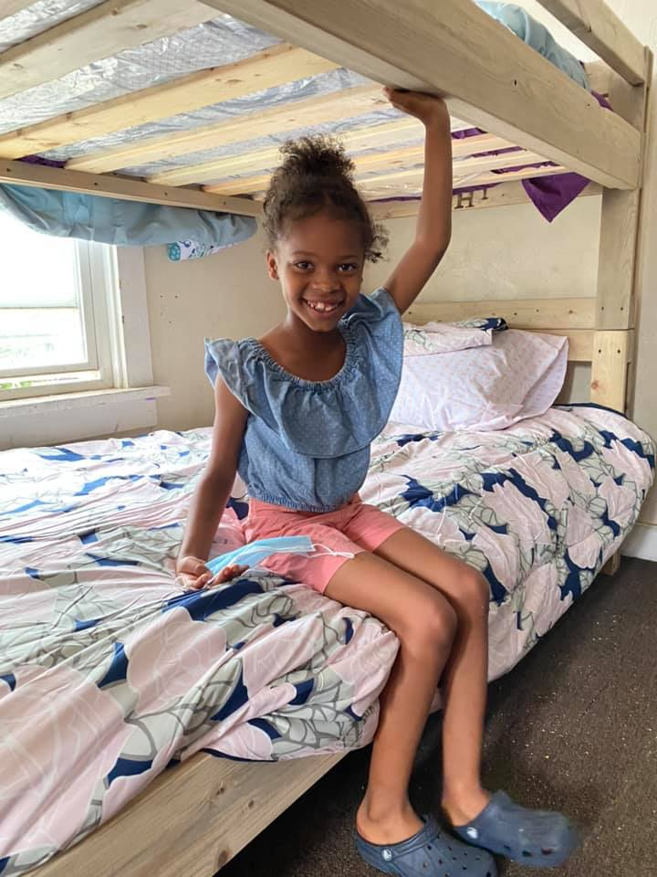
The further the reach of the organization, the sooner the heartwarming stories spread about children who no longer have to sleep on the floor, or on a sleeping bag, or three to a bed. The immediate reward is meeting people during the building process; the ultimate reward is watching the elation on children’s faces when you assemble a new bed that they can call their own.
This commitment to children began in 2012 when Luke Mickelson was asked by his church congregation to build a bed for a girl who was sleeping on a nest of clothes on the floor. He measured his own daughter’s bed as a model, cut and sanded lumber in his garage, and assembled it. Beyond the joy of this child, Mickelson sensed a greater need. Within a year, he built and donated 11 more beds. SHP has since mushroomed to more than 250 chapters nationwide and spread to Canada and Bermuda.
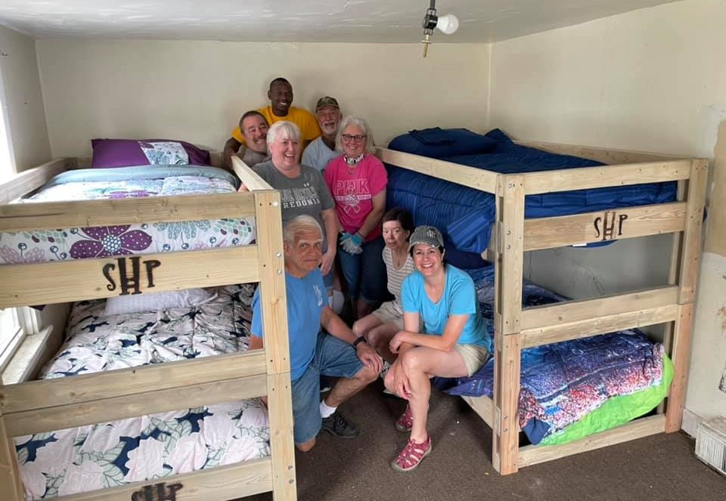
Donna Ritchie and an installer team from Ogden Presbyterian Church.
My Rochester chapter has delivered more than 150 beds in the last 18 months, and our wait list has grown to more than 300 beds. So the motto – “No Kid Sleeps on the Floor in Our Town!” – remains our top goal.
Our local chapter founders, Shawn and Donna Ritchie, had volunteered frequently through youth soccer, Girl Scouts and church leadership, but they were intrigued when their daughter, Meg, returned home from a trip to Michigan. Her friends were running a SHP chapter and filled her with stories about the needs of children, making beds and organizing volunteers.
“When we looked into it, we just knew we had the skills, connections and drive to pull it off,’’ Donna said. “Still, we hesitated for a few weeks while we mulled it over.’’
“While we were thinking and stalling, we were in church when the sermon topic was from James, ‘Faith without works is dead.’ We agreed it was a sign that we were meant to take the leap, so we filled out the form to apply to start a chapter. The next thing we knew, we were on a plane to Idaho for chapter president training.’’
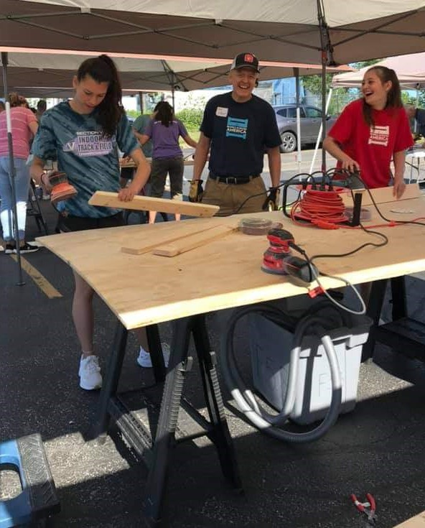
My wife Mary was one of their first recruits when Donna convinced her to volunteer for a two-hour shift. I agreed to come along on a Saturday morning in March 2020, just before the pandemic closings were starting. We began sanding pine boards in a chilly shed, and chatting with volunteers. Our two hours grew to six. We were hooked by the spirit of the volunteers. In a few months, we were delivering and installing beds, reveling in the smiles and elation of children who each received a mattress and a set of sheets, a pillow and a comforter.
1Shawn Ritchie guides the sanding team.
The bedmaking process is already defined and refined, thanks to the generosity in our community. We borrow a flatbed trailer and have been given an enclosed trailer for hauling wood and equipment. We’ve received sanders, drills and drivers, and lumber from Lowe’s. We graduated from our chilly shed to donated warehouse space, where we set up drilling, sanding and cutting stations. We store bedding and mattresses there. We’ve become nimble enough to pack our trailers and set up building projects outdoors in our parking lot or at local churches or businesses.
Last weekend was a typical effort when we took our act on the road to partner with Beyond The Sanctuary based out of Memorial AME Zion Church, which was connected to the Underground Railroad and where Frederick Douglass 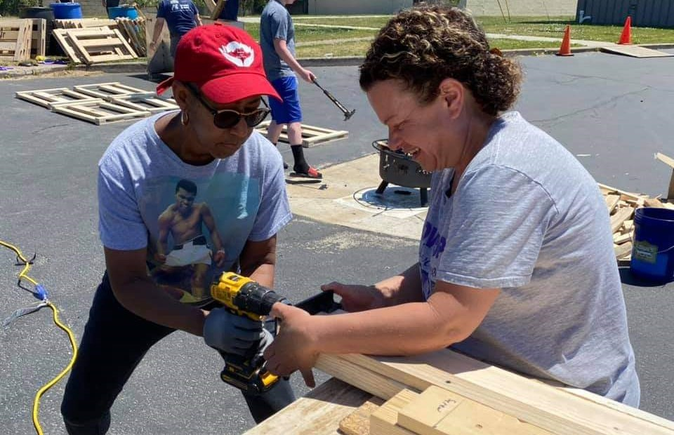
Drilling a pilot hole into a siderail.
worshipped during his Rochester years.
Thursday night: Shawn and Donna gathered a handful of volunteers at the shop to cut lumber, often donated by Lowe’s, for siderails, headboards and safety rails. All the cuts were loaded onto a flatbed trailer for Zion’s parking lot.
Friday night: They filled the enclosed trailer with a dunk tank, barrels of vinegar for staining, sanders and drivers, tables, extension cords and a drill press.
Saturday morning: Shawn directs the unloading, sets up work tables, runs power cords and arranges lumber. Donna sets up a registration table for volunteers, then writes on the pavement in sidewalk chalk to outline how raw lumber will move through the stations – sanding, siderails and headboards, drilling, dunking, branding and assembling bed kits that go back on the trailers.
Volunteers: We have employed an array of generous people. My daughter’s college cross country coach brought the Alfred State College alumni chapter as volunteers. Ogden Presbyterian volunteers were so motivated by their build that they helped at AME Zion’s project. My favorite was the 90-pound girls from Victor who developed a jumping technique so they could sink wood screws into the headboards.
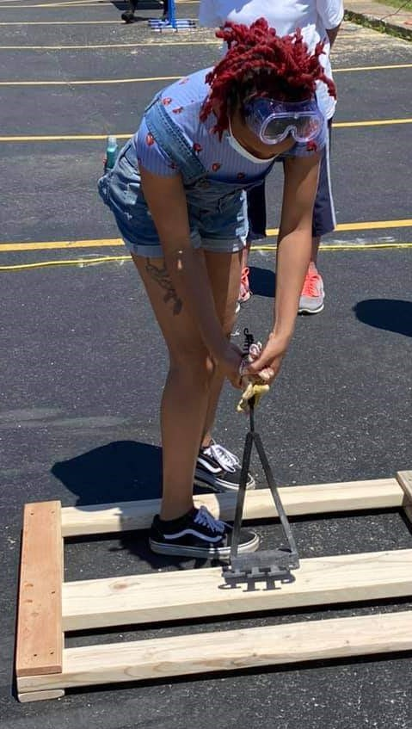
Branding and dunking: We light a fire pit at each build to heat branding irons, then volunteers burn the SHP logo into each headboard. Then the headboards and siderails are dipped in a tank filled with vinegar and steel wool. Together, they form a seal that discourages bed bugs.
FA volunteer applies the SHP brand to a headboard.
Napping: That’s reserved for late Saturday, and often Sundays too, once the equipment is stowed and sunburns are addressed.
The bed kits are returned to the warehouse. On another weekend, teams will head into neighborhoods to install singles and bunkbeds in the bedrooms of needy children.
“I don't remember all the names, but I remember the kids, their excitement and smiles,’’ Donna recalled. “I also remember some of the conditions our kids are living in and it's tough. This is one thing we can do to help, so we have to be satisfied with that.’’
SHP’s website -- https://www.shpbeds.org/ -- displays buttons where parents can request a bed for children ages 3-17 or inquire about starting a chapter.
“The New York chapters are pretty tight,’’ Donna said. “We share war stories, help each other out and give each other advice - not to mention tools!’’
The Ritchies work fulltime. Shawn installs trams, mostly for waterside properties. Donna manages event planning for Rochester Area Community Foundation. Their volunteering can be exhausting, but they plug along.
“I don’t know about keeping up momentum, but I'm not worried about it,’’ Donna said. “We'll have volunteers come and go, but we'll just keep trying to help as many kids as possible.’’
Jim Holleran, a Morristown native, is a retired teacher and registrar for the Rochester City School District, and former sports editor of the Democrat and Chronicle. Reach him at jimholleran29@gmail.com or view past columns at https://hollerangetsitwrite.files.wordpress.com under Reflections of a River Rat.

